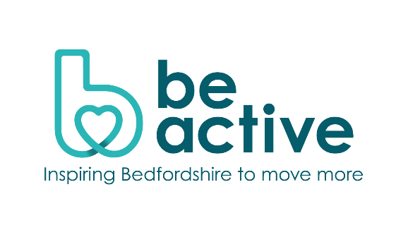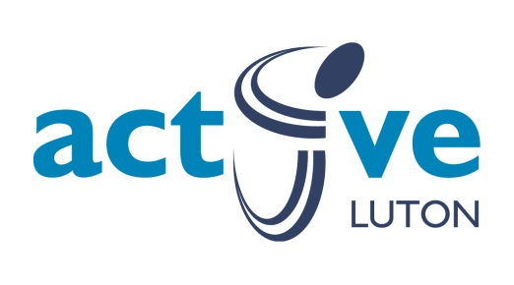

**Marketing Officer (4 days a week)**

**Be Active**

**Active Partnership**

A tremendous opportunity for a passionate and talented individual to take on the role within the Active Partnership team as the Marketing Officer. We’re looking for a marketing professional with a passion for storytelling to join us in our mission to increase physical activity across Bedfordshire.

This is an exciting opportunity to elevate our narrative across a variety of media, creating engaging content that resonates with our community and partners.

You will need to understand the role of the **Active Partnership** – [**Be Active**](https://www.beactivebeds.co.uk/) and our remit in terms of underpinning the Sport England Strategy in engaging the inactive market. You will need to demonstrate a desire to add value to a successful team.

You will support the team in marketing and promotion. Create, design and update marketing initiatives, promotional materials and visual imagery. Lead the online presence of Be Active including website, social media and all aspects of e-communications. Ensure effective use of all marketing materials on corporate and sub brands.

This post will involve some flexibility around working from home and other bases, with travel around Bedfordshire expected as well as minimal regional and national travel.

Be Active has a strong reputation locally, regionally, and nationally. Can you make the team even better?

For an informal discussion about this post, please contact Johnathan Rudland via email [johnathan@teambedsandluton.co.uk](mailto:johnathan@teambedsandluton.co.uk) . To apply, please follow the link below.

Vacancy:

Marketing Officer - £30,027 (full time equivalent)

**Closing Date: Midday 25th October 2024**